Query 1

SELECT MONTH(HireDate) AS 'Month', Count([HumanResources].[Employee].[BusinessEntityID]) as "Number of Employees" FROM [HumanResources].[Employee] Group BY MONTH(HireDate)

QUERY -1 IMAGE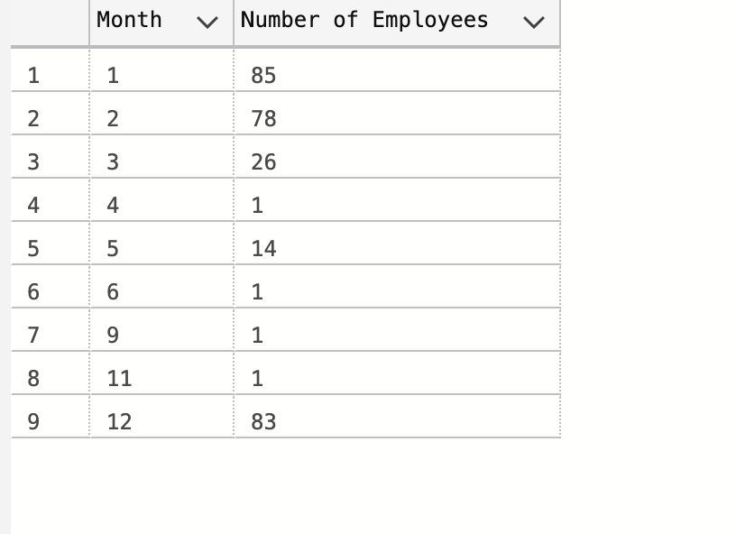

Query 2 :

select [HumanResources].[Department].Name,count([HumanResources].[Employee].BusinessEntityID) "No of Employees", Year([HumanResources].[Employee].HireDate ) as 'hireYear' from [HumanResources].[Employee]

left join [HumanResources].[EmployeeDepartmentHistory]

on ([HumanResources].[EmployeeDepartmentHistory].BusinessEntityID =[HumanResources].[Employee].BusinessEntityID )

left Join [HumanResources].[Department]

on

([HumanResources].[EmployeeDepartmentHistory].DepartmentID=[HumanResources].[Department].DepartmentID)

GROUP by (Year([HumanResources].[Employee].HireDate )),([HumanResources].[Department].Name)

QUERY 2 IMAGE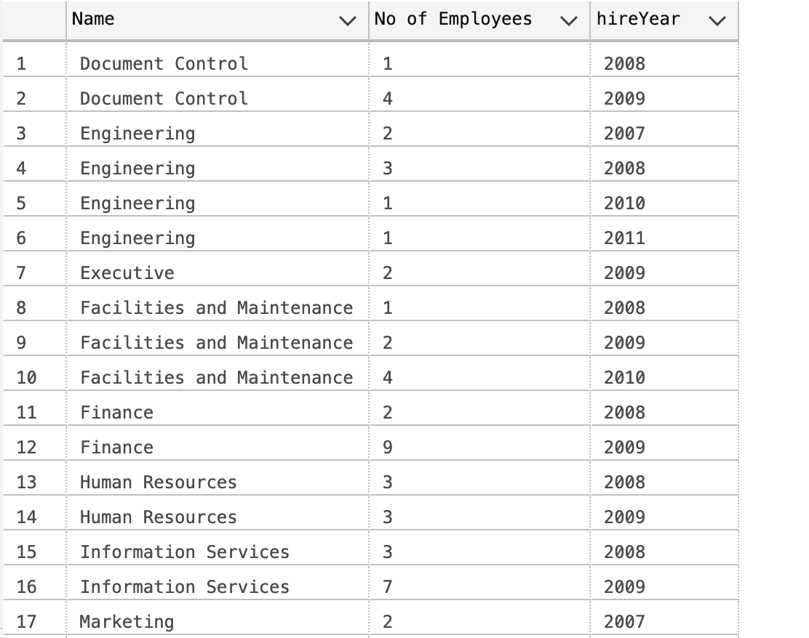

QUERY - 3

select P.FirstName , CR.Name

from [AdventureWorks2019].[HumanResources].[Employee] as E

left join [AdventureWorks2019].[Person].[Person] P

on E.[BusinessEntityID] <> P.[BusinessEntityID]

left join [AdventureWorks2019].[Person].[BusinessEntityAddress] as BEA

on P.[BusinessEntityID] = BEA.[BusinessEntityID]

left join [AdventureWorks2019].[Person].[Address] A

on A.[AddressID]= BEA.[AddressID]

left join [AdventureWorks2019].[Person].[StateProvince] SP

on SP.[StateProvinceID]=A.[StateProvinceID]

left join [AdventureWorks2019].[Person].[CountryRegion] CR

on CR.[CountryRegionCode] = SP.[CountryRegionCode]

where P.FirstName like 'S%'

QUERY 5 Image

Query 5

SELECT P.[ProductID] ,P.[Name],E.[TransactionDate],

(select SUM(Q.[Quantity]) from [AdventureWorks2019].[Production].[TransactionHistory] Q where(P.[ProductID]=Q.[ProductID]))

As "Cumulative Quantity"

, (select SUM(Q.[ActualCost]) from [Adve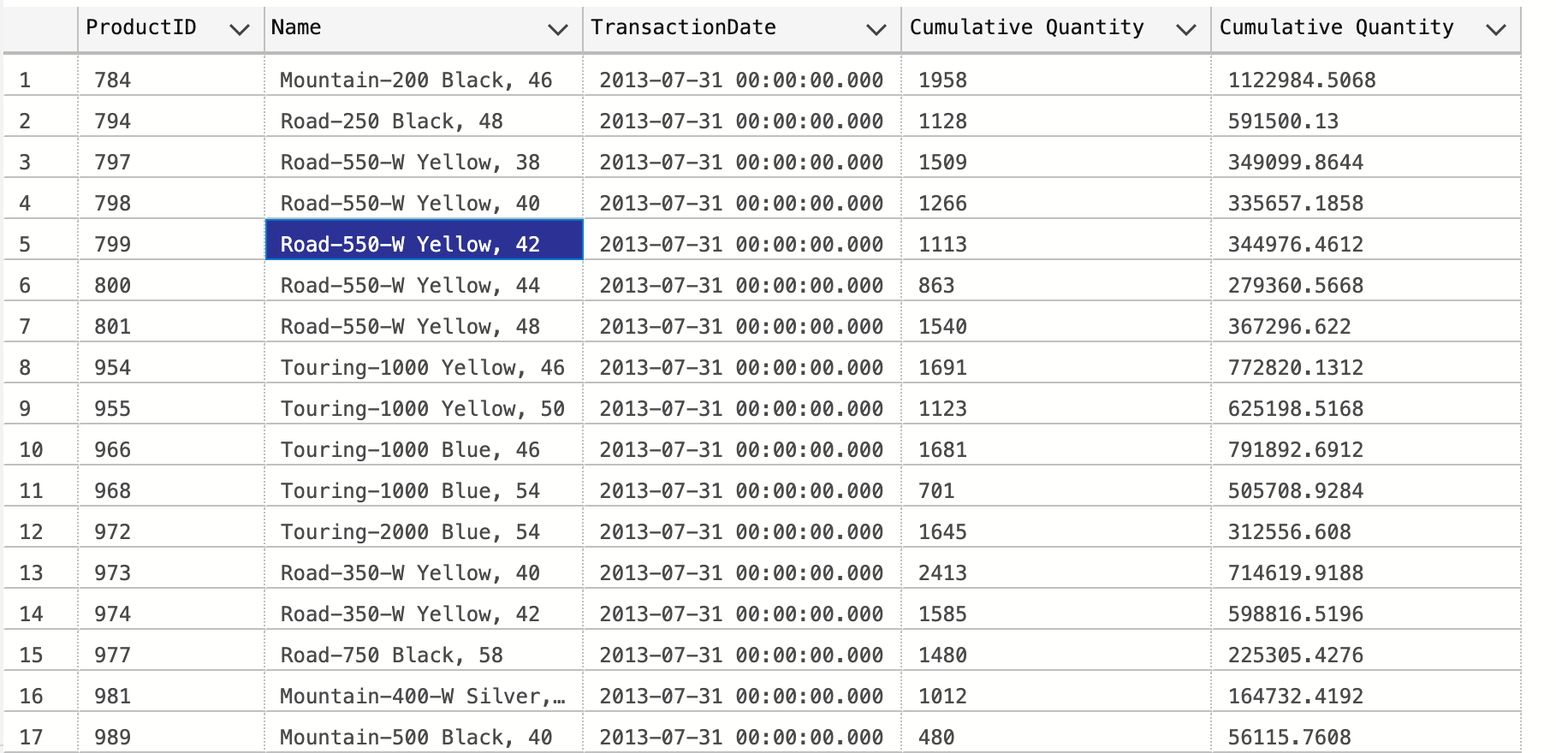ntureWorks2019].[Production].[TransactionHistory] Q where(P.[ProductID]=Q.[ProductID]))

As "Cumulative Quantity"

FROM [AdventureWorks2019].[Production].[Product] as P

left JOIN [AdventureWorks2019].[Production].[TransactionHistory] E

ON (P.[ProductID]=E.[ProductID])

QUERY 9 Image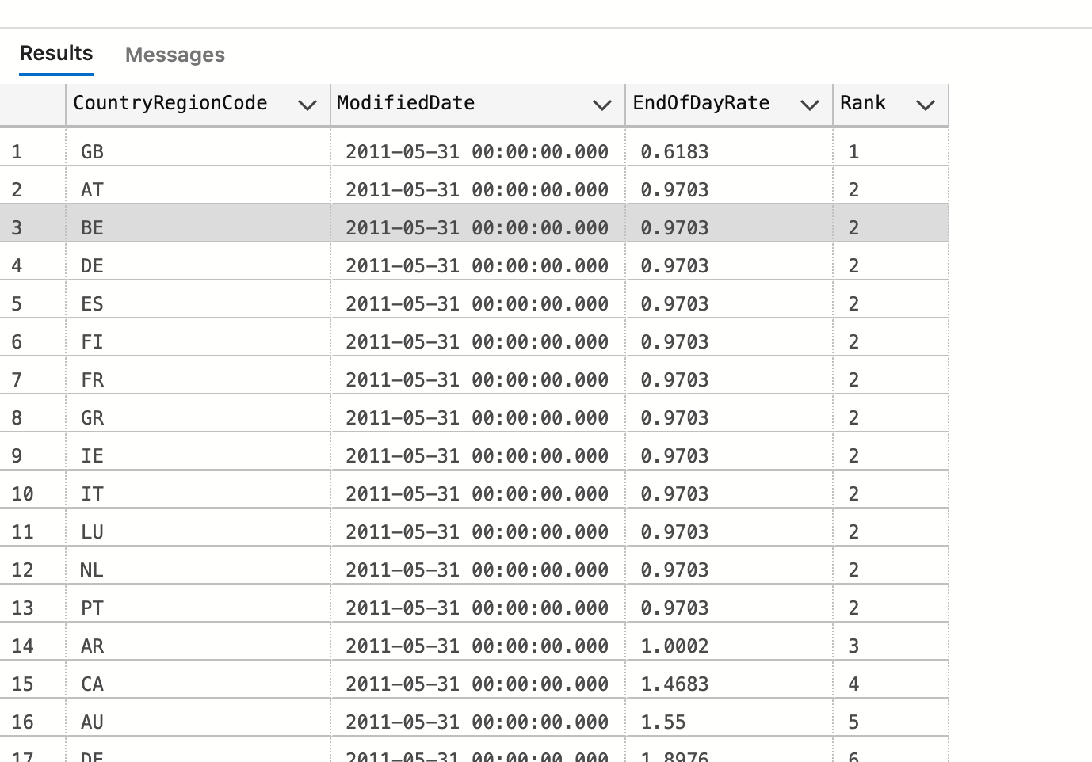

QUERY - 9

SELECT [Sales].CountryRegionCurrency.CountryRegionCode, [Sales].[CurrencyRate].ModifiedDate, [sales].[CurrencyRate].EndOfDayRate,

DENSE_RANK() OVER(Partition by [Sales].[CurrencyRate].ModifiedDate Order BY EndOfDayRate) as Rank

FROM [Sales].CountryRegionCurrency

JOIN [Sales].CurrencyRate

on CountryRegionCurrency.CurrencyCode=CurrencyRate.ToCurrencyCode;

QUERY 10 Image

QUERY - 10

SELECT  P.Name, CC.CreditCardID,SOH.SalesOrderID, CC.ExpMonth,  SOH.OrderDate

FROM [Sales].[CreditCard] as CC

JOIN [Sales].[SalesOrderHeader] SOH

ON CC.Cred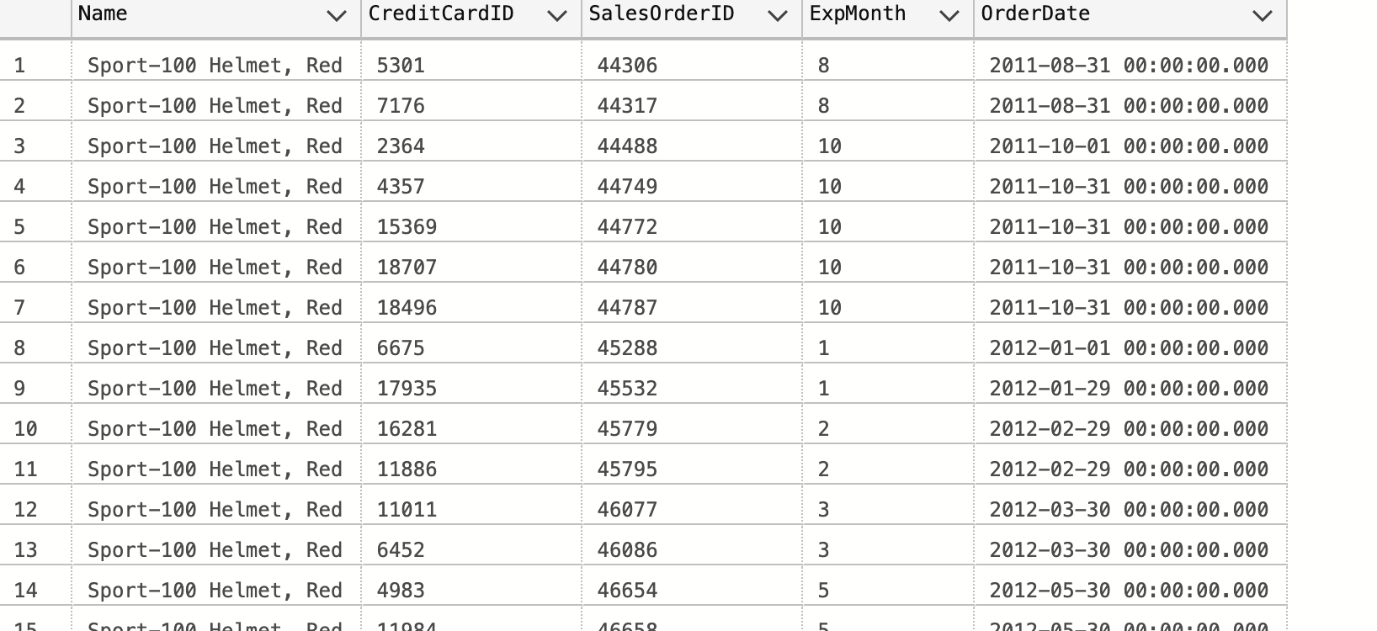itCardID=SOH.CreditCardID

JOIN [Sales].[SalesOrderDetail] as SOD

ON SOD.SalesOrderID=SOH.SalesOrderID

JOIN [Production].Product as P

On SOD.ProductID=P.ProductID

WHERE CC.ExpMonth=Month(SOH.OrderDate);